**Angular Assignment**

**Github Link:** <https://github.com/Heena110297/Covid-app>

**Surge link:** [swanky-quiet.surge.sh](http://swanky-quiet.surge.sh)

**Credentials: email –** [**admin@xyz.com**](mailto:admin@xyz.com) **, password - 123456**

**Working flow:**

**Login Component –** Whenever admin logins, a token is stored in the local storage which is valid for 24 hrs. if the token exists, user is considered to be logged in. When the user logs out his information along with the token is deleted from the local storage

**Dashboard Component** –

* Any user can view state data which is fetched from the api provided.
* When a user clicks on the state name, he will be able to see the district data of that state as well.
* User can also find the data of a single state by filtering the data displayed in the table.
* User can also sort the data for example: user can sort the data according to the highest number of confirmed cases.

**News Component-**

* Normal users can view the news
* Admin can add, edit and delete news
* Admin cannot add back-dated news

**Precaution Component-**

* Normal users can view precautions.
* Admin can add, edit and delete precaution

**Screenshots:**

**TestCase Execution:**

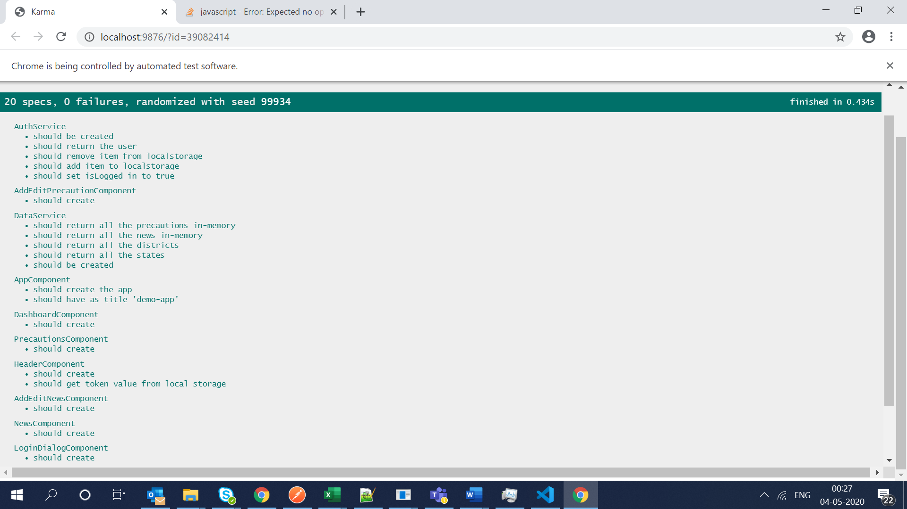

**District Data**

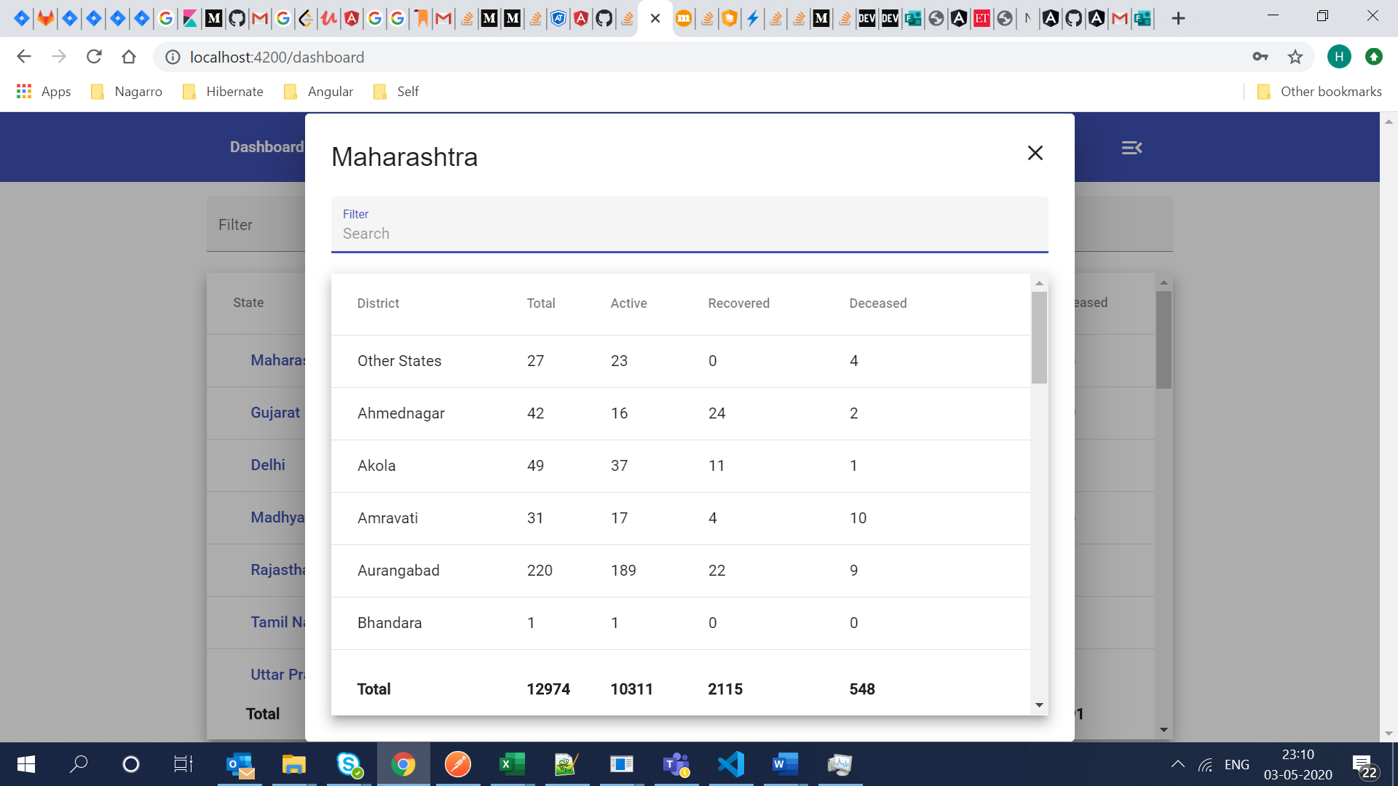

**News for general users**

**Precautions for general users**

**Precautions for the admin**

**Add Precaution for admin:**

**Add News for the Admin**

